DOCUMENT 1:
Paul Leroy-Beaulieu: On Imperialism (1891)

“The present-day world is composed of four different categories in terms of types of civilization.

The first is that of Western civilization--our own part. A second part is inhabited by people of a different civilization, but organized in compact, coherent and stable societies and destined by their history and present character to govern themselves--the Chinese and Japanese peoples for example. In the third part live peoples advanced enough in some respects, but ones which have either deteriorated or ones that have not been able to.... Finally, a great part of the world is inhabited by barbarian tribes or savages, some given over to wars without end and to brutal customs, and others knowing so little of the arts and being so little accustomed to work and to invention that they do not know how to exploit their land and its natural riches. They live in little groups, impoverished and scattered, in enormous territories which could nourish vast numbers of people with ease.

This state of the world implies for the civilized people a right of intervention . . . In the affairs of the peoples of the last two categories. “

DOCUMENT 15:

Mark Twain, Returning Home, an article in New York World (1900)

“You ask me about what is called imperialism. Well, I have formed views about that
question…I don't think that it is wise or a necessary development. We have no more business in… any other country that is not ours. There is the case of the Philippines. I have tried hard, and yet I cannot for the life of me comprehend how we got into that mess. Perhaps we could not have avoided it -- perhaps it was inevitable that we should
come to be fighting the natives of those islands -- but I cannot understand it, and have never been able to get at the bottom of the origin of our resentment towards the natives.

I thought we should act as their protector -- not try to get them under our control. We were to relieve them from Spanish rule to enable them to set up a government of their own, and we were to stand by and see that it got a fair trial. It was not to be a government according to our ideas, but a government that represented the feeling of the majority of the Filipinos, a government according to Filipino ideas. That would have been a worthy mission for the United States.

But now -- why, we have got into a mess, a quagmire from which each fresh step renders the difficulty of getting out immensely greater.”

DOCUMENT 3:

This excerpt was written by American Senator A.J. Beveridge in 1898.

“American factories are making more than the American people can use; American soil is producing more than they can consume. Fate has written our policy for us; the trade of the world must and shall be ours. . . . We will establish trading posts throughout the world as distributing points for American products. We will cover the ocean with our merchant marines. We will build a navy to the measure of our greatness. . . .”

DOCUMENT 4:

In this excerpt, author Parker T. Moon pointed out which groups were most interested in imperialism.
”The makers of cotton and iron goods have been very much interested in imperialism. This group of import interests has been greatly strengthened by the demand of giant industries for colonial raw materials. . . . Ship-owners demand coaling stations for their vessels and naval bases for protection. To these interests may be added the makers of armaments and of uniforms. The producers of telegraph and railway material and other supplies used by the government in its colony may also be included. . . . Finally, the most powerful business groups are the bankers. Banks make loans to colonies and backward countries for building railways and steamship lines.”

DOCUMENT 5:

Cecil Rhodes, on African Imperialism:

“I contend that we [Britons] are the finest race in the world, and the more of the world we inhabit, the better it is for the human race. . . . It is our duty to seize every opportunity of acquiring more territory and we should keep this one idea steadily before our eyes that more territory simply means more of the Anglo-Saxon race, more of the best, the most human, most honourable race the world possesses.”

DOCUMENT 13:

US President William McKinley on the Philippines.
“We could not leave them (Filipinos) to themselves. They were unfit for self-government. There was nothing left for us to do but to take them over. Then we would be able to educate the Filipinos. We could uplift and civilize and Christianize them. . . .”

DOCUMENT 7:

Phan Thanh Gian, governor of a region in Vietnam, retranslation from Focus on World History: The Era of the First Global Age and Revolution, Walch Publishing, 2002 (adapted)
“Now, the French come, with their powerful weapons of war, to cause dissension among us. We are weak against them; our commanders and our soldiers have been vanquished. . . . The French have immense warships, filled with soldiers and armed with huge cannons. No one can resist them. They go where they want, the strongest ramparts [walls, fortifications] fall before them.”

DOCUMENT 12:

Capt. F. D. Lugard, African Explorer and Colonial Administrator, 1893

“It is sufficient to reiterate [repeat] here that, as long as our policy is one of free trade, we are compelled to seek new markets; for old ones are being closed to us by hostile tariffs*, and our great dependencies, which formerly were the consumers of our goods, are now becoming our commercial rivals. It is essential in a great colonial and commercial empire like ours that we go forward or go backward. To allow other nations to develop new fields, and to refuse to do so ourselves, is to go backward; and this is the more deplorable…”

*Tariffs are taxes countries place on imports or exports

DOCUMENT 9:

Rule, Britannia was a popular British song celebrating the British Navy in the 1700s and 1800s

When Britain first, at heaven’s command,
Arose from out the azure main,
Arose, arose, arose from out the azure [blue] main.
This was the charter, the charter of the land,
And guardian angels sang the strain.

Rule Britannia!
Britannia rule the waves.
Britons never, never, never shall be slaves.

DOCUMENT 10:

French economist Charles Gide writing in 1885

“If we consider particularly the case of France the arguments of the adversaries of a colonial policy take on a special force.

First, regarding population migration, France has no one to spare. Its population is sparse and grows so slowly that it is only foreign immigration that will fill the country. France ... has no merchandise to export. French industry specializes in making expensive and high quality goods. It is not for selling to the Chinese who live on a fistful of rice, nor for the Blacks of the Congo who dress in a swatch of cotton cloth…

The profits that the people living in a country make from starting colonies appears uncertain; the profit that the government could make seems even more problematic. The revenue (money, profit) is the goal that governments pursue when setting up colonies, but experience teaches them that this is a mirage.”

DOCUMENT 20:

John A. Hobson, a British economist and writer, published Imperialism: A Study in 1902

“Although the new Imperialism has been bad business for the nation, it has been good business for certain classes and certain trades within the nation. The vast expenditure [spending]on armaments [weapons], the costly wars, the grave risks and embarrassments of foreign policy, the stoppage of political and social reforms within Great Britain, though fraught with great injury to the nation, have served well the present business interests of certain industries and professions.

If the millions of dollars which may now be taken as a minimum expenditure on armaments in time of peace were subjected to a close analysis, most of it would be traced directly to the cashboxes of certain big firms engaged in building warships and transports, equipping and coaling them, manufacturing guns, rifles, and ammunition, supplying horses, wagons, food, clothing for the services, contracting for barracks, and for other large irregular needs.”

DOCUMENT 19:

A letter from British missionary John G. Paton about the New Hebrides Islands, a group of islands in the South Pacific now known as the nation of Vanuatu (1883)

“The thirteen islands of this group on which life and property are now comparatively safe, the 8,000 professed Christians on the group, and all the churches formed from among them are, by God’s blessing, the fruits of the labors of British missionaries, who, at great toil, expense, and loss of life have translated, got printed, and taught the natives to read the Bible in part or in whole in nine different languages of this group, while 70,000 at least are longing and ready for the gospel.

On this group twenty-one members of the mission families died or were murdered by the savages in beginning God’s work among them, not including good Bishop Peterson, of the Melanesian mission, and we fear all this good work would be lost if the New Hebrides fall into other than British hands.”

DOCUMENT 18:

“The Rhodes Colossus”

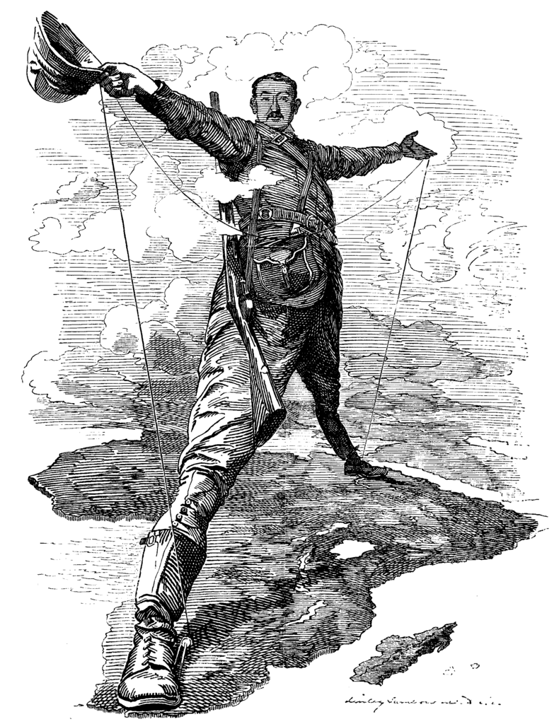

DOCUMENT 8:

Lipton Tea Advertisement, 1890 (Ceylon was controlled by the British for about 150 years, now called the nation of Sri Lanka)

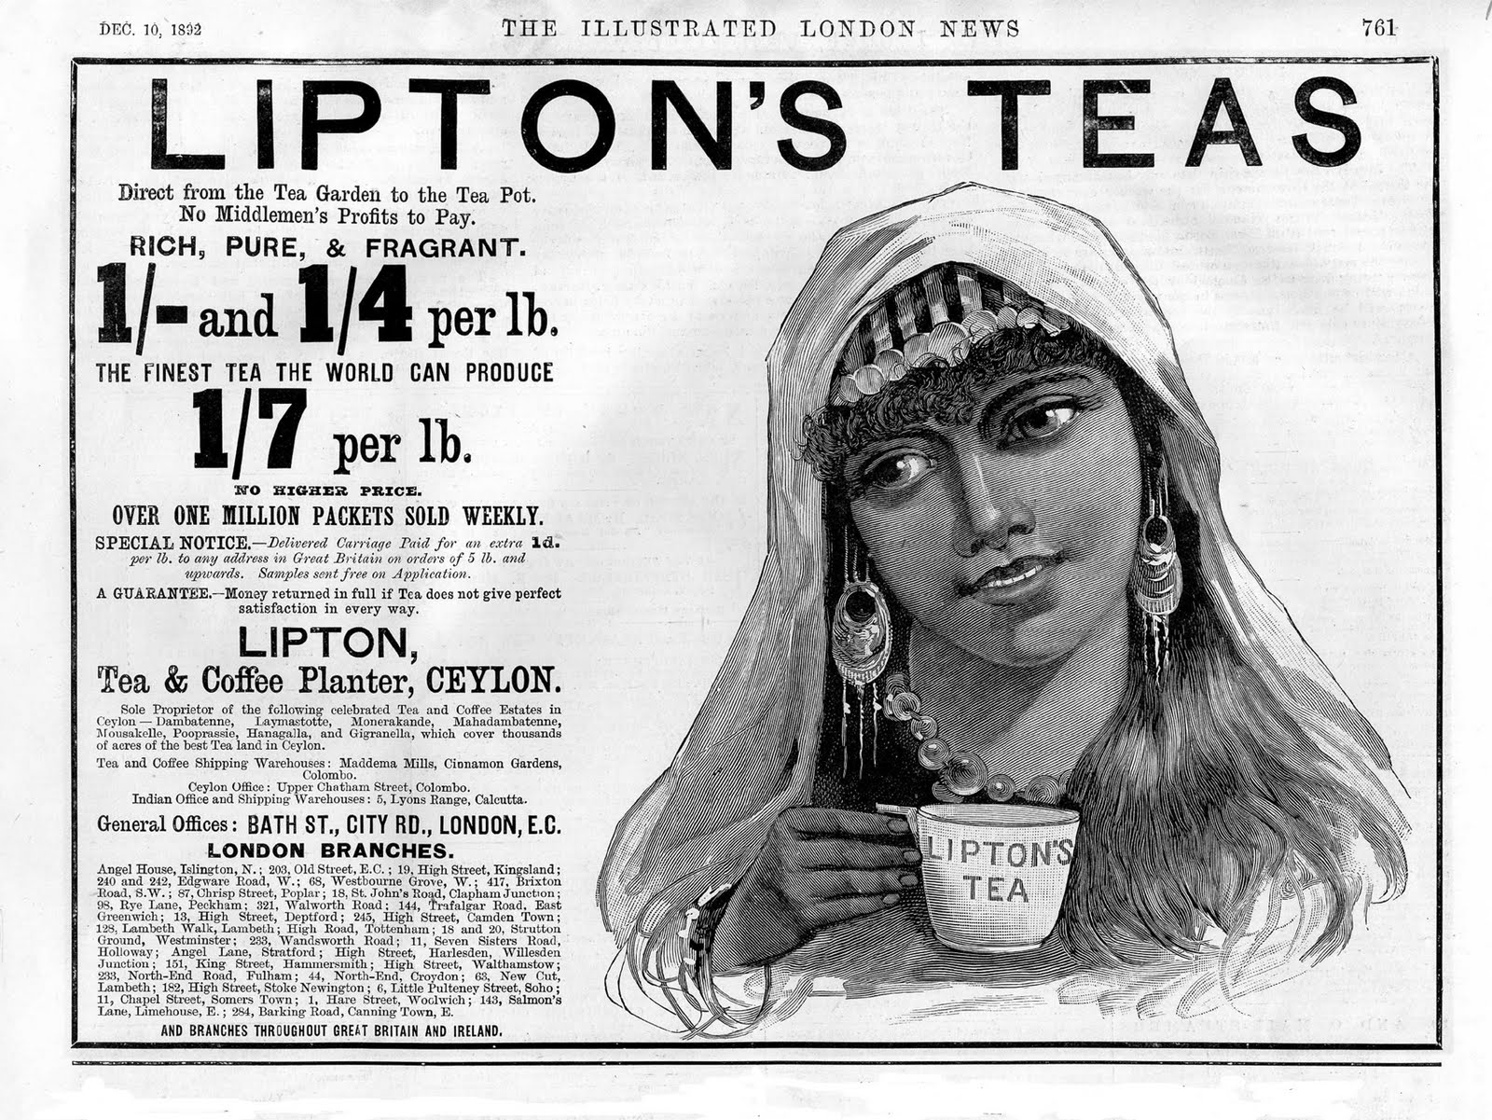

DOCUMENT 6:

Political cartoon, 1890s regarding China

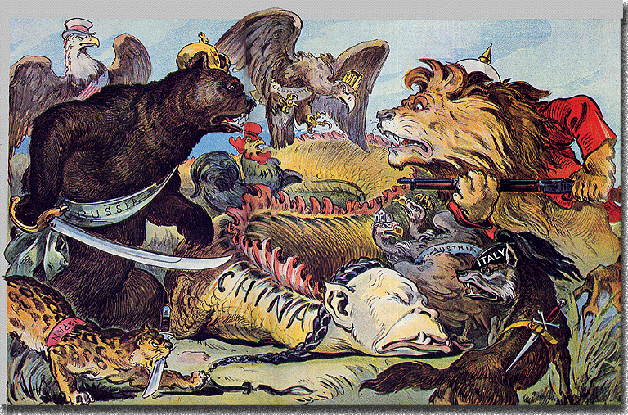

DOCUMENT 14:

Open Shaft mining in Kimberly, South Africa 1872

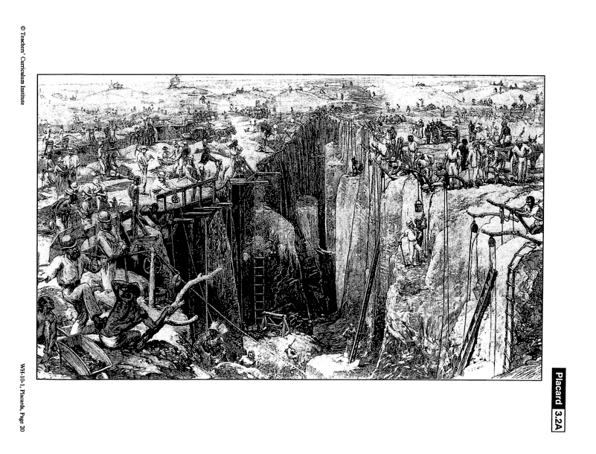

DOCUMENT 2:

German flag flying in Cameroon, 1891

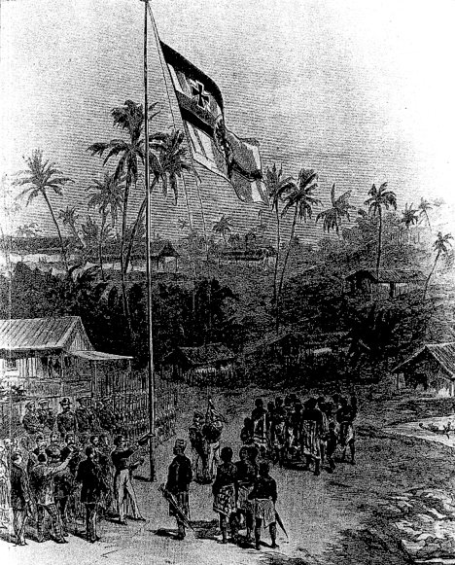

DOCUMENT 16:

Map of Africa published in Europe prior to 1854

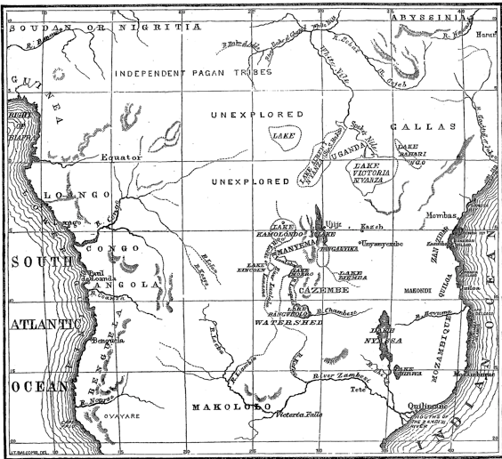

DOCUMENT 17:

“The Partition of China”, 1897

The Heathen Chinee! The Heathen Chinee!
What a channel for Christian Expansion is he
Then Ho! For the Flowery Land of the East,
Like vultures we’ll swoop on the promising feast.
Commission your Navies, ye Nations so free
To bear the true light to the Heathen Chinee

If Russia ‘makes converts’, it’s perfectly clear
We need for ‘converting’ a well-defined sphere
If Germany’s ‘missions’ hold meetings for prayer,
So Christian a work ‘tis our duty to share.
Incidentally, too, there is cash to be made;
There’s naught like Religion to stimulate Trade

DOCUMENT 11:
Images of the Ivory Trade in the Congo, 1800s
