INTRODUCTION
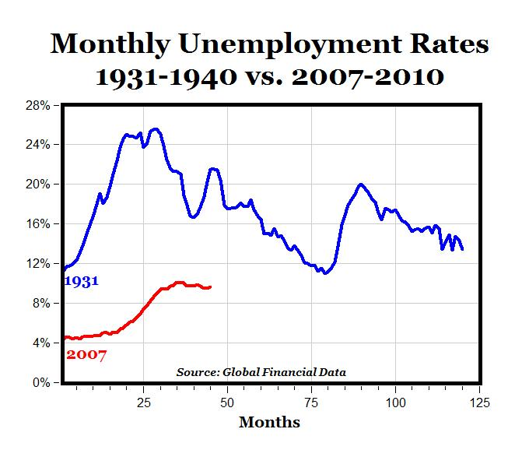
The Great Recession is an ongoing marked global economic decline that began in December 2007 and took a particularly sharp downward turn in September 2008. is considered by many economists the worst financial crisis since the Great Depression of the 1930s. It resulted in the threat of total collapse of large financial institutions, the bailout of banks by national governments, and downturns in stock markets around the world. In many areas, the housing market also suffered, resulting in evictions, foreclosures and prolonged unemployment. The crisis played a significant role in the failure of key businesses, declines in consumer wealth estimated in trillions of U.S. dollars, and a downturn in economic activity leading to the 2008–2012 global recession and contributing to the European sovereign-debt crisis.
The bursting of the U.S. housing bubble, where the median price for real estate home sales in US started to decline after its peak in July 2006, caused the values of securities tied to U.S. real estate pricing to plummet, damaging financial institutions globally and creating an interbank credit crisis. The first sign of an interbank credit crisis arrived in March 2007, when the United States' subprime mortgage industry collapsed due to higher-than-expected home foreclosure rates, with more than 25 subprime lenders declaring bankruptcy, announcing significant losses, or putting themselves up for sale.
The Great Recession began as a national recession in United States in December 2007, but only met the criteria for being a global recession, in the single calendar year 2009. The recession affected the entire world economy, with greater detriment to some countries than others, but overall to a degree which made it the worst global recession since World War II.
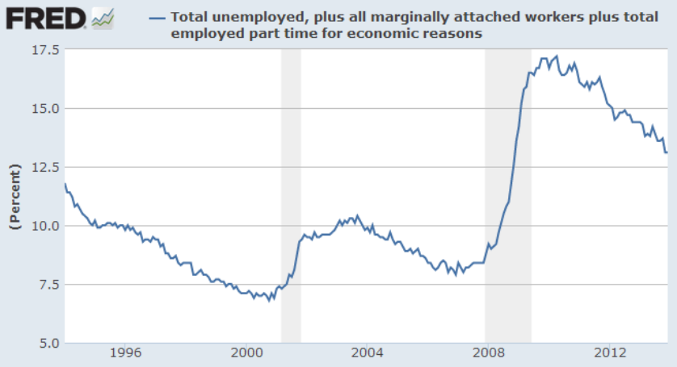
Percentage of people unemployed during the Great Recession.
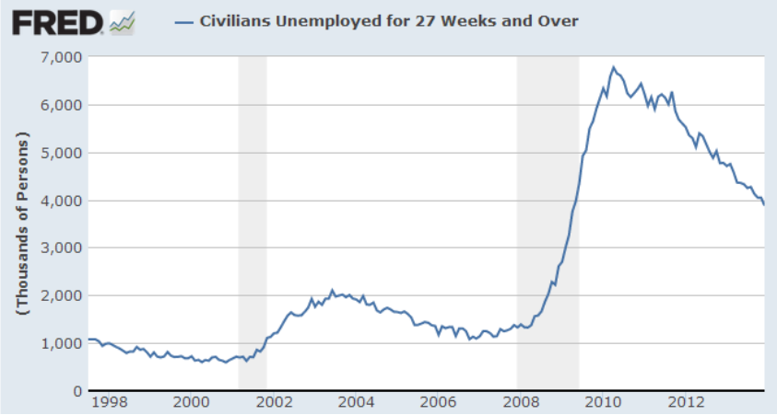
Long-term unemployment.
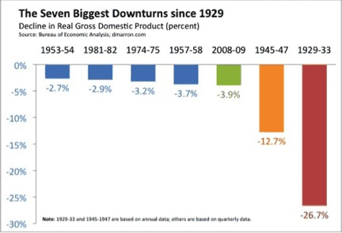

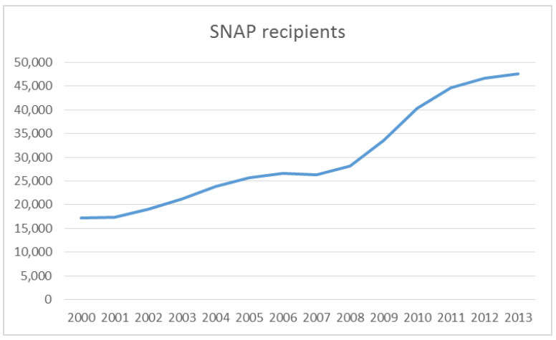
Rise in the percentage of people claiming SNAP benefits (food stamps).

DOCUMENT 1

The Great Recession
Economists generally agree this is the worst economic downturn since the Great Depression, but they say despite pain, another depression isn't likely.
By Chris Isidore, CNNMoney.com senior writer
Last Updated: March 25, 2009: 5:19 PM ET

NEW YORK (CNNMoney.com) -- Is this the worst economy since the Great Depression? And what are the chances of the economy falling into another depression?

The answer to the first question is fairly clear. In most ways that matter to economists and average Americans, this is the worst economic crisis since the Depression.

The answer to the second question is not as clear. While the National Bureau of Economic Research officially declares the beginning and end of recessions, nobody does that for depressions.

Still, the general consensus of economists is that another depression is not likely. But the risks are greater than they were only a few months ago.

Why this recession is so bad
First things first: Even though it may seem obvious to most that this is the worst downturn since the Great Depression, the economy has experienced other serious recessions in the past, particularly in the mid-1970s and early 1980s.

But this recession dwarfs those two for several reasons.

In terms of length, the longest post-Depression economic decline was 16 months, which occurred in both the 1973-75 and 1981-82 recessions. This recession began in December 2007, which means that it will enter its 17th month next Wednesday.

The current recession is also more widespread than any other since the Depression. The Federal Reserve's readings show that 86% of industries have cut back production since November, the most widespread reduction in the 42 years the Fed has tracked this figure.

What's more, every state reported an increase in unemployment this past December, the first time that has happened in the 32 years that records for unemployment in each state have been kept.

"This is important because there's nowhere you can move to find a job," said Gus Faucher, director of macroeconomics for Moody's Economy.com.

Finally, during the past nine months, the drop in household wealth has been larger since anything on record in the post-World War II period.
Why this won't be another depression

So far during this recession, the nation's gross domestic product, the broadest measure of economic activity, has dropped about 1.7%. Forecasts of experts surveyed by the National Association for Business Economics work out to about a 3.4% decline in GDP over the life of this recession.

To be sure, there already have been some quarters where the drop was much more severe. The government will report its final revision of GDP for the fourth quarter of 2008 and economists are expecting that report to show an annual rate of decline of 6.6%. And some economists think the drop in the first quarter could be even greater.

But measuring the drop in economic activity from top to bottom is how economists judge a recession's depth. And a 3.4% drop would be the worst since World War II, and far worse than the average recession in that period. Still, that's a long way from the 26.5% drop in GDP that took place between 1929 and 1933.

One of the main reasons why economists think another depression could be avoided is that it will take more than just a sharp decline in consumer spending and household wealth to spark a depression.

Even though household net worth has fallen a record $11 trillion, or 18%, during the course of this recession, the broader economy can weather such a shock.

Historically, stock market crashes and bursting housing bubbles haven't necessarily led to depressions. It takes a variety of economic factors and policy decisions to turn a recession into something even more serious.

"I don't know if you can make a causal link between a loss of wealth and a depression," said Lakshman Achuthan, managing director of Economic Cycle Research Institute.
Learning lessons of the 1930s

Significant policy changes since the 1930s will also cushion the blow.

Unemployment insurance, Social Security payments and larger government at the federal, state and local levels keep money flowing into the economy even as consumers and businesses pull back on their own spending.

"There's a lot more safeguards in place," said Keith Hembre, chief economist at First American Funds. Hembre said the $787 billion stimulus bill passed by Congress in February will also spur more economic activity down the road.

In addition, the Federal Reserve, led by Great Depression expert Ben Bernanke, has pumped trillions of dollars into the economy with new lending programs the central bank has never tried before. That has swelled the supply of money. By way of contrast, the money supply tightened during the Great Depression.

There were many other policy mistakes made in the 1930s that economists say are not being repeated today, including stiff tariffs that killed international trade and government imposed limits on prices and production levels.

But some economists aren't completely ruling out another depression. In a paper for the National Bureau of Economic Research last month, Harvard University professors Robert Barro and Jose Ursua put the chance of a minor depression (which they defined as a GDP decline of at least 10%) at about 20% and a 3% chance of a major depression (defined as a GDP drop of at least 25%). Moody's Economy.com is forecasting a 10% chance of a depression.

Document 2

PoliticsUSA.com
Explaining the Recession: Housing and the U.S. Economic Collapse
How did we get to the point of near economic collapse? Let us first take a look at the housing market, as we have heard a lot about why this is an important part of the financial crisis.

We have heard the term ‘housing bubble’ thrown around. However, what does that necessarily mean? Well, over a period of time, starting in the ’90s but taking place primarily between 2001 and 2007, real estate values soared. People were seeing the values of their homes double, sometimes triple, over the course of just a couple of years.

One of the reasons behind these inflated values was that lending institutions were doing anything they could to make loans for anyone and everyone. With more people able to purchase homes, more homes were sold, and thus, the values of the surrounding homes were able to go up.

These lending institutions (banks, mortgage companies, etc.) made a conscious decision, in the interest of short-term profits, to make more ’sub-prime’ loans. [Basically, a sub-prime loan is a loan made to a person who under normal guidelines would not qualify for a loan, based on a number of reasons. These reasons could be one of the following: lack of verifiable income and/or resources to pay back the loan, poor payment history, not enough money for a down payment or lack of equity to refinance. Any of these things, or a combination along with other variables, would normally prevent someone from obtaining a mortgage loan.]

However, more and more, lenders decided that this was an untapped market and, basically, a lot of money could be made. And, in the short term, that is very much true. As these borrowers didn’t really have a choice (other than not getting a loan at all), the lenders would make these loans at much higher interest rates, as well as higher fees assessed at closing. Much of the time, the loans were set-up with the interest rates adjusting after 2-3 years, meaning that the interest rate would in all likelihood increase sharply after that time frame.

When looking at it now, it seems the height of irresponsibility. Eventually, all of this irresponsible lending would catch up with the economy. With all of the quickly inflated values of homes and people both purchasing and refinancing these properties, defaults on these loans started piling up. The simple explanation is people were given loans they could not afford.

Document 3
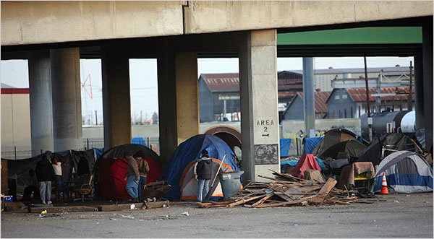
New York Times
March 26, 2009
Cities Deal With a Surge in Shantytowns
By JESSE McKINLEY

FRESNO, Calif. — Like a dozen or so other cities across the nation, Fresno is dealing with an unhappy déjà vu: the arrival of modern-day Hoovervilles, illegal encampments of homeless people that are reminiscent, on a far smaller scale, of Depression-era shantytowns. At his news conference on Tuesday night, President Obama was asked directly about the tent cities and responded by saying that it was “not acceptable for children and families to be without a roof over their heads in a country as wealthy as ours.”

While encampments and street living have always been a part of the landscape in big cities like Los Angeles and New York, these new tent cities have taken root — or grown from smaller enclaves of the homeless as more people lose jobs and housing — in such disparate places as Nashville, Olympia, Wash., and St. Petersburg, Fla.

In Seattle, homeless residents in the city’s 100-person encampment call it Nickelsville, an unflattering reference to the mayor, Greg Nickels. A tent city in Sacramento prompted Gov. Arnold Schwarzenegger to announce a plan Wednesday to shift the entire 125-person encampment to a nearby fairground. That came after a recent visit by “The Oprah Winfrey Show” set off such a news media stampede that some fed-up homeless people complained of overexposure and said they just wanted to be left alone.

The problem in Fresno is different in that it is both chronic and largely outside the national limelight. Homelessness here has long been fed by the ups and downs in seasonal and subsistence jobs in agriculture, but now the recession has cast a wider net and drawn in hundreds of the newly homeless — from hitchhikers to truck drivers to electricians.

“These are able-bodied folks that did day labor, at minimum wage or better, who were previously able to house themselves based on their income,” said Michael Stoops, the executive director of the National Coalition for the Homeless, an advocacy group based in Washington.

The surging number of homeless people in Fresno, a city of 500,000 people, has been a surprise. City officials say they have three major encampments near downtown and smaller settlements along two highways. All told, as many 2,000 people are homeless here, according to Gregory Barfield, the city’s homeless prevention and policy manager. On a recent afternoon, nobody seemed thrilled to be living in New Jack City, a filthy collection of rain- and wind-battered tents in a garbage-strewn lot. Several weary-looking residents sat on decaying sofas as a pair of pit bulls chained to a fence howled.

Northwest of New Jack City sits a somewhat less grim encampment. It is sometimes called Taco Flats or Little Tijuana because of the large number of Latino residents, many of whom were drawn to Fresno on the promise of agricultural jobs, which have dried up in the face of the poor economy and a three-year drought.

Guillermo Flores, 32, said he had looked for work in the fields and in fast food, but had found nothing. For the last eight months, he has collected cans, recycling them for $5 to $10 a day, and lived in a hand-built, three-room shack, a home that he takes pride in, with a door, clean sheets on his bed and a bowl full of fresh apples in his propane-powered kitchen area.

“I just built it because I need it,” said Mr. Flores.

Document 4

